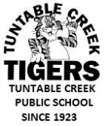
Tuntable Creek Public School is committed to Making a Difference.
It is important that we empower students with responsibility for the environment, encouraging commitment to sustainability for the future.
We are also committed to building strong partnerships with our community.
Tuntable Creek Public School
RESPECT-INTEGRITY -PARTICIPATION
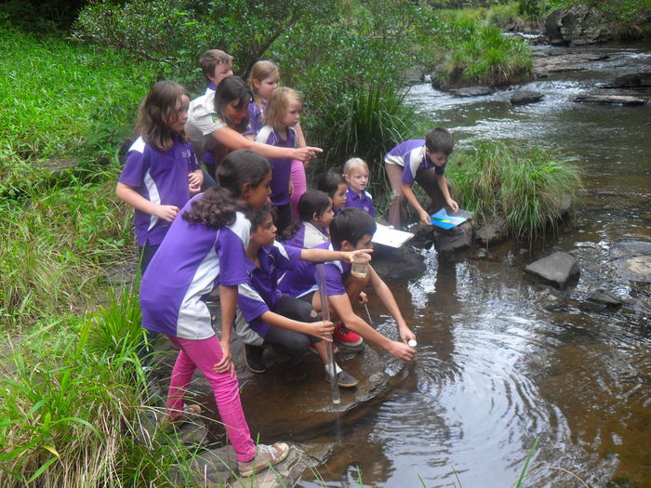

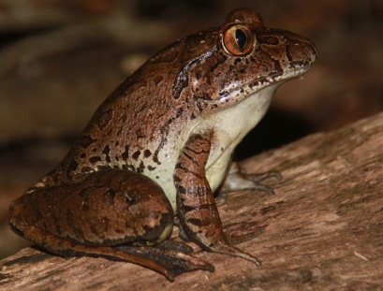

Giant Barred Frog Project
Improving Endangered Frog Habitat in Tuntable Creek
Together with Tuntable Creek Landcare we seek to:
- Build upon conservation efforts already undertaken in the area
- Increase the area of habitat suitable for the Giant Barred Frog
- Increase community awareness of the Giant Barred Frog.
Long term conservation of the Giant Barred Frog is reliant upon vital habitat protection and rehabilitation to improve conservation management.
Giant Barred Frogs are the second largest species of Australian frog, up to 115 mm in length. Having disappeared from much of their former distribution along the humid east coast of Australia, they are now a critically endangered species.

What can you do to help?
We would like to invite you to come and have a chat about our project at Tuntable Creek Public School- Tuntable Creek Road, The Channon
Date: Tuesday 28th October Time: 1:30-5:30 Afternoon tea provided
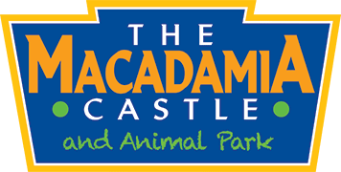
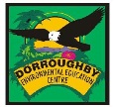
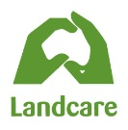
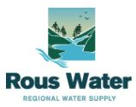
Come and meet the different organisations that are helping our school to make a difference- Tuntable Creek Landcare, Macadamia Castle, Richmond Landcare, Rous Water and Dorroughby EEC.
This community project received funding through the NRMA Insurance Community Grants program, Tuntable Creek Landcare and Taronga Zoo.

